Contents

Introduction 2

Meaningful Use Stage 1 Requirements 2

Core objectives 2

Computerized Provider Order Entry (CPOE) 3

E-Prescribing (eRx) 4

Provide patients with an electronic copy of their health information, upon request 5

Provide clinical summaries for patients for each office visit 8

Drug-drug and drug-allergy interaction checks 10

Maintain active medication list 11

Maintain active medication allergy list 12

Record and chart changes in vital signs 13

Record demographics 15

Report ambulatory clinical quality measures to CMS/States 17

Record smoking status for patients 13 years or older 17

Capability to exchange key clinical information among providers of care 19

Maintain an up-to-date problem list of current and active diagnoses 19

Implement one clinical decision support rule 20

Protect electronic health information 21

Menu Set 22

Drug-formulary checks 22

Generate lists of patients by specific conditions 22

Provide patients with timely electronic access to their health information 24

Medication reconciliation 26

Use certified EHR technology to identify patient-specific education resources and provide to patient, if appropriate 27

Incorporate clinical lab test results as structured data 29

Send reminders to patients per patient preference for preventive/follow up care 30

Summary of care record for each transition of care/referrals 30

Public Health objectives 31

1. Capability to submit electronic data to immunization registries/systems 31

2. Capability to provide electronic syndromic surveillance data to public health agencies 32

# 

# Introduction

The Medicare and Medicaid EHR Incentive Programs provide financial incentives for the “meaningful use” of certified EHR technology to improve patient care. To receive an EHR incentive payment, providers have to show that they are “meaningfully using” their EHRs by meeting thresholds for a number of objectives. CMS has established the objectives for “meaningful use” that eligible professionals, eligible hospitals, and critical access hospitals (CAHs) must meet in order to receive an incentive payment.

## Meaningful Use Stage 1 Requirements

Eligible Professionals (EP) must complete:

1. [15 Core Objectives](http://www.hitecla.org/print/meaningful_use_requirements#Meaningful_Use_Core_Objectives)
2. [5 objectives out of 10 from Menu Set](http://www.hitecla.org/print/meaningful_use_requirements#Meaningful_Use_Menu_Set)
3. [6 total Clinical Quality Measures (CQM)](http://www.hitecla.org/print/meaningful_use_requirements#Core_Clinical_Quality_Measures) 
   * [3 core](http://www.hitecla.org/print/meaningful_use_requirements#Core_Clinical_Quality_Measures)
   * [3 out of 38 from Additional Set](http://www.hitecla.org/print/meaningful_use_requirements#Additional_Set_of_CQMs)
   * [Reporting of CQM](http://www.hitecla.org/print/meaningful_use_requirements#Reporting_Clinical_Quality_Measures)

In this document we will discuss the how we achieve the 15 core objectives and 10 Menu set objectives through the ZH openEMR.

# Core objectives

The 15 core objectives are listed below

1. Computerized Provider Order Entry (CPOE)
2. E-Prescribing (eRx)
3. Report ambulatory clinical quality measures to CMS/States
4. Implement one clinical decision support rule
5. Provide patients with an electronic copy of their health information, upon request
6. Provide clinical summaries for patients for each office visit
7. Drug-drug and drug-allergy interaction checks
8. Record demographics
9. Maintain an up-to-date problem list of current and active diagnoses
10. Maintain active medication list
11. Maintain active medication allergy list
12. Record and chart changes in vital signs
13. Record smoking status for patients 13 years or older
14. Capability to exchange key clinical information among providers of care
15. Protect electronic health information

We will discuss the core objectives one by one.

## Computerized Provider Order Entry (CPOE)

Description: Computer provider order entry (CPOE) allows a physician to electronically enter orders medication, lab services, imaging studies, and other services from a computer or mobile device. CPOE also captures the order and saves it as data in the patient’s electronic record.

Objective: Computer provider order entry (CPOE) for medication orders.

Measure: More than 30% of patients with at least one medication in their medication list have at least one medication ordered through CPOE.

**Calculation:**

Numerator – Number of Patients who have at least one medication order entered using CPOE

Denominator – Number of unique patients with at least one medication in their medication list seen by the physician during the EHR Reporting Period

Result – If the result of the calculation is more than 30%, the physician has met this requirement.

**Exclusions and Other Considerations:**

1. Physicians who write fewer than 100 prescriptions during the EHR reporting period are excluded from this Objective.

2. This objective is limited to only medication orders.

3. It is only required that the physician enter the order using CPOE. Transmission of the order is not required for Stage 1 meaningful use.

4. The objective is based on unique patients, regardless of how many times an individual patient is seen or how many prescriptions an individual patient receives.

**How to mark**

Enter medication in the e-prescribe (through the med entry or through compose Rx) and the CPOE criterion will be satisfied.

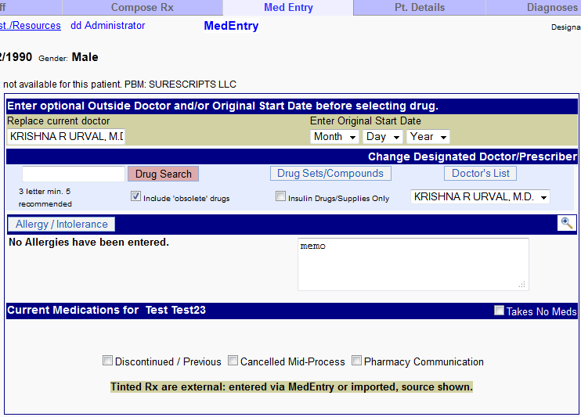

## E-Prescribing (eRx)

Description: Electronic prescribing (“e-prescribing”) systems allow physicians to electronically enter and transmit prescriptions. While many physicians use “stand-alone” e-prescribing systems, the capability to e-prescribe is a requirement of certified EHR systems.

Objective: Generate and transmit permissible prescriptions electronically

Measure: More than 40% are transmitted electronically using certified EHR technology.

**Calculation:**

Numerator – The number of prescriptions generated and transmitted electronically.

Denominator – The total number of prescriptions written for drugs requiring a prescription in order to be dispensed other than controlled substances during the EHR Reporting Period.

Result – The resulting percentage must be more than 40% for a physician to meet this objective.

**Exclusions and Other Considerations:**

1. Despite recent regulations allowing electronic prescribing of Schedule II drugs, they are not counted in this calculation as “permissible prescriptions.”

2. Physician authorization for things other than drugs, such as lab tests and durable medical equipment, is not considered for the purposes of this measure.

3. A prescription only needs to be transmitted electronically to count for this measure. It can be received in any format. For example, some e-prescribing systems can take electronic prescriptions and convert them into faxes.

**How to mark**

Using e-prescription module will satisfy the above.

## Provide patients with an electronic copy of their health information, upon request

Description: The purpose of this objective is to provide patients access to all of their health information in a human readable format. The objective does not define exactly what is included in “health information,” but gives several examples. The intent is to provide patients with as much information as possible.

Objective: On request, provide patients with an electronic copy of their health information (including diagnostic test results, problem list, medication lists, and medication allergies).

Measure: More than 50% of requesting patients receive electronic copy within 3 business days.

**Calculation:**

Numerator – The number of patients who request their health information who receive it within three business days.

Denominator – The number of patients seen during the EHR Reporting period who request their health information.

Result – The resulting percentage must be more than 50% for the physician to meet this objective.

**Exclusions and Other Considerations:**

1. If a physician has no requests from patients for their health information during the reporting period, that physician is excluded from this objective.

2. Physicians are allowed to withhold information that would potentially be harmful to the patient.

3. Physicians are allowed to charge a fee for copying information, per HIPAA regulations.

4. Patients are allowed to choose the format in which they receive their information.

5. Disclosure of the information to a parent, family member, or caretaker is allowed under this objective.

**How to mark**

Here we have to provide an electronic copy of the health information either through a CD or through patient portal.

Denominator: - Once we select a patient, we can go to the ‘Patient/Client’ tab, then under ‘Records’ we have the option for ‘patient record request’. Here in this screen, we have the option to place a patient record request.

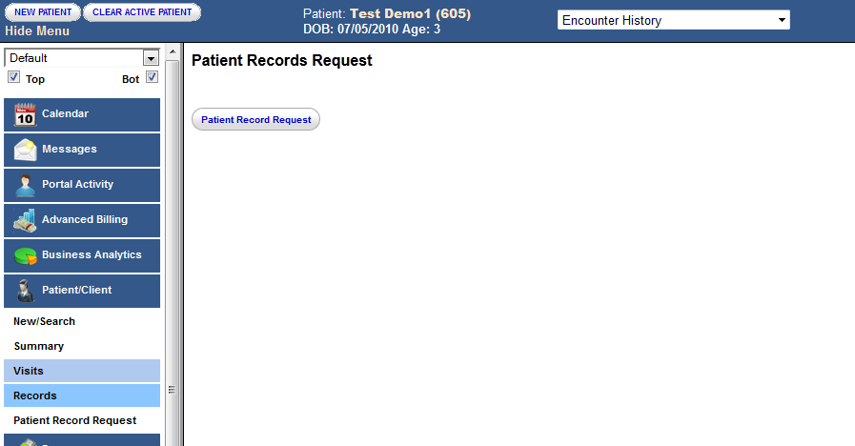

Once the request has been placed we get the following screen

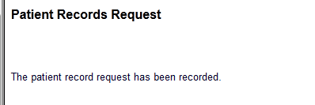

Numerator: - Under Reports -> clinic -> AMC Tracking, we have the option to check the patient record requests between certain dates as shown below. Here we have the option to put a check box on ‘yes’ once the patient record is provided and then we will have the denominator recorded.

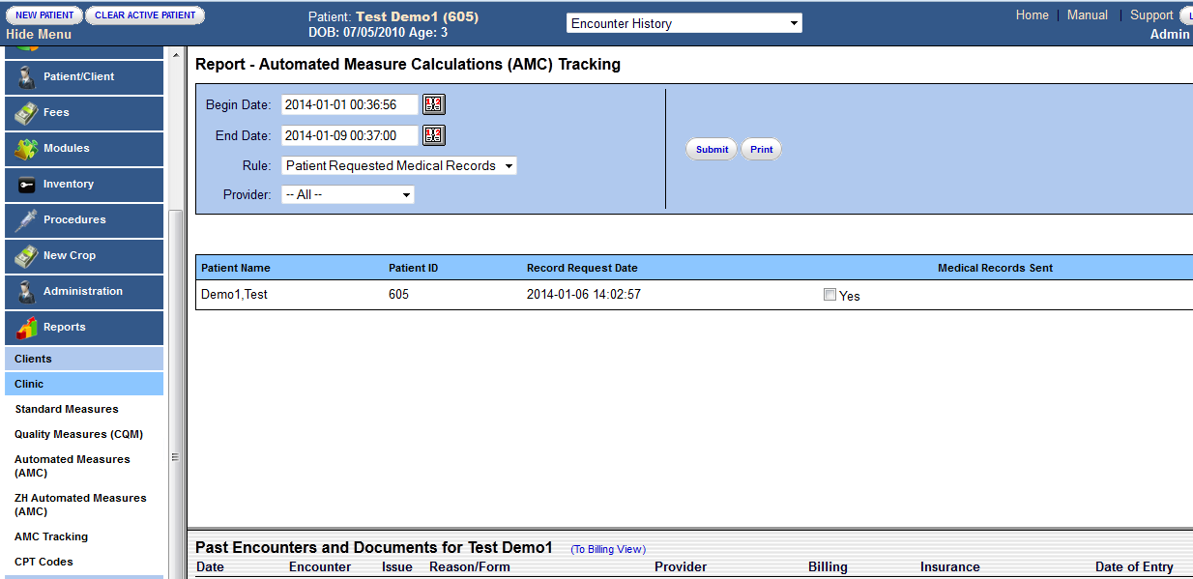

## Provide clinical summaries for patients for each office visit

Description: The rule defines a clinical summary as:

“an after-visit summary that provides a patient with relevant and actionable information and instructions containing, but not limited to, the patient name, provider’s office contact information, date and location of visit, an updated medication list and summary of current medications, updated vitals, reason(s) for visit, procedures and other instructions based on clinical discussions that took place during the office visit, any updates to a problem list, immunizations or medications administered during visit, summary of topics covered/considered during visit, time and location of next appointment/testing if scheduled, or a recommended appointment time if not scheduled, list of other appointments and testing patient needs to schedule with contact information, recommended patient decision aids, laboratory and other diagnostic test orders, test/laboratory results (if received before 24 hours after visit), and symptoms.”

Objective: Provide patients with clinical summaries for each office visit.

Measure: Clinical summaries provided to patients for more than 50% of all office visits within 3 business days

**Calculation:**

Numerator – The number of patients who are provided a clinical summary of their visit within three business days.

Denominator – The number of unique patients seen by the physician during the EHR Reporting Period.

Result – The resulting percentage must be more than 50% for the physician to meet this objective.

**Exclusions and Other Considerations:**

1. Physicians are allowed to withhold information that would potentially be harmful to the patient.

2. The clinical summary can be provided in any form – paper copy, CD, USB device, secure email, or through a patient portal.

3. Physicians who have no office visits during the EHR Reporting Period are excluded from this rule.

4. This objective is based on unique patients, regardless of the number of times any individual patient is seen.

**How to mark**

Denominator: - Every patient that comes in for a visit will be taken as the numerator.

Numerator: - We have to give the patient a summary of the visit (We can give a print of the doctor’s notes). Thereafter, in the notes there is a checkbox shown below that needs to be checked.

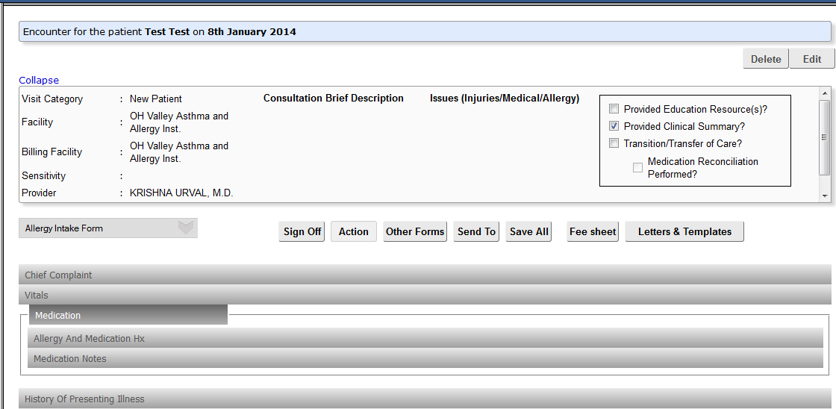

## Drug-drug and drug-allergy interaction checks

Description: Many EHR systems provide warnings when a prescribed medication may possibly conflict with another medication the patient is currently taking, or may cause an adverse allergic reaction. EHRs certified for meaningful use must contain this capability.

Many EHRs, however, allow physicians to disable drug-drug and drug-allergy checks. This objective requires the physician to enable these checks.

Objective: Implement drug-drug and drug-allergy interaction checks.

Measure: Functionality is enabled for these checks for the entire reporting period.

**Calculation**: Not applicable.

**Exclusions and Other Considerations:**

1. Physicians who write fewer than 100 prescriptions during the reporting period are excluded from this objective.

2. This objective does not require a physician to enable drug-formulary checks, although that is a menu item for Stage 1 of meaningful use. It will be required in Stage 2.

**Note**: - This will be automatically taken care of e prescription module is used.

## Maintain active medication list

Description: An active medication list is defined as a list of medications that a patient is currently taken. The list includes both prescription medications and, to the extent they are known, over-the-counter drugs.

In an EHR system, a medication list is recorded as “structured” data. That is, the system not only records the word “aspirin,” it recognizes that aspirin is a medication. It is important that the data be structured, since an active medication list allows drug-drug interaction checks to function properly.

Objective: Maintain active medication list.

Measure: More than 80% of patients have at least one entry recorded as structured data.

**Calculation:**

Numerator – The number of patients who have a medication (or an indication that the patient is not currently taking any medications) recorded as structured data.

Denominator – The number of unique patients seen by the physician during the EHR Reporting Period.

Result – The percentage must be greater than 80% for the physician to meet this objective.

**Exclusions and Other Considerations:**

1. A physician is allowed to record that a patient has no current medications.

2. The calculation is based on unique patients seen by the physician, regardless of the number of times any individual patient is seen, or the number of medications any individual patient has.

3. This rule does not override a patient’s right to privacy. A physician will not be held responsible for recording medications that the patient does not disclose.

**How to mark**

In the e-prescription module we need to do the following

Numerator: - Here we need to either enter the medication or we need to mark the patient as ‘takes no meds’. Medications can be entered by doing a drug search in the e-prescribe window shown below.

Denominator: - The number of unique patients seen by the physician during the EHR Reporting Period.

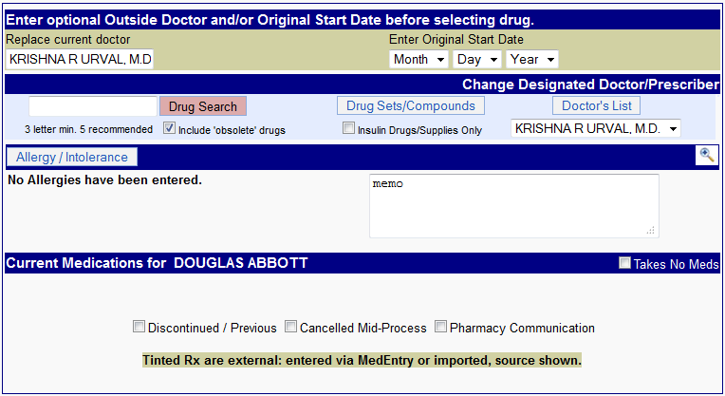

## Maintain active medication allergy list

Description: An active medication allergy list records all known medication allergies. It can be constructed either through patient disclosure, or through the regular course of treatment.

Certified EHR systems will record medication allergies as “structured” data. That is, the EHR will be able to compare a prescribed medication to the list of medication allergies and alert providers to possible conflicts.

Objective: Maintain active medication allergy list.

Measure: More than 80% of patients have at least one entry recorded as structured data.

**Calculation:**

Numerator – The number of unique patients who have at least one entry (or an indication that the patient has no known medication allergies) recorded as structured data.

Denominator – The number of unique patients seen by the physician during the EHR Reporting Period.

Result – The resulting percentage must be higher than 80% for the physician to meet this objective.

**Exclusions and Other Considerations:**

1. A physician is allowed to record that a patient has no known medication allergies.

2. The calculation is based on unique patients seen by the physician, regardless of the number of times any individual patient is seen, or the number of medication allergies any individual patient has.

**How to mark**

In the e-prescription module, we need to either enter the allergies or we need to put in ‘No Known Allergies’

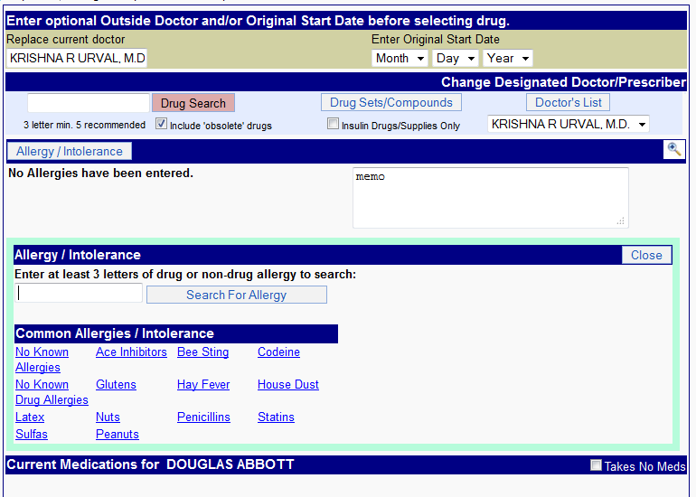

## Record and chart changes in vital signs

Description: This objective would require a physician to record a patient’s height, weight, and blood pressure. This data is essential for tracking potentially harmful changes in a patient’s health.

Certified EHR technology will be able to calculate a patient’s body mass index (BMI) or growth chart (for children and adolescents) based on the entered data. It is not necessary for the physician to separately enter this data.

Objective: Record vital signs and chart changes (height, weight, blood pressure, body-mass index, growth charts for children).

Measure: More than 50% of patients 2 years of age or older have height, weight, and blood pressure recorded as structured data.

**Calculation:**

Numerator – The number of patients who have at least one entry of their height, weight, and blood pressure recorded as structured data.

Denominator – The number of unique patients age 2 or over seen by the physician during the EHR Reporting Period.

Result – The resulting percentage must be higher than 50% for the physician to meet this objective.

**Exclusions and Other Considerations:**

1. A physician who believes that recording a patient’s height, weight, and blood pressure is not relevant to their scope of practice would be able to attest to that fact.

2. Physicians who do not see patients over the age of 2 are excluded from this requirement.

3. The vital signs need not be updated at every patient visit.

4. A patient’s height can be self-reported.

**How to mark**

Denominator: - It is system generated on the basis of the denominator criterion.

Numerator: - We have to enter the vitals (height, weight and blood pressure) in the vitals chart shown below.

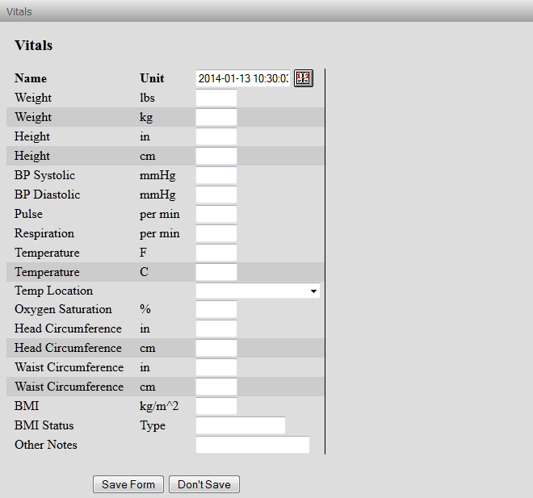

## Record demographics

Description: Patient demographic data includes the patient’s sex, race, ethnicity, date of birth, and preferred language. The rule requires that physicians record this data following current federal standards published by the Office of Management and Budget: (<http://www.whitehouse.gov/omb/inforeg_statpolicy/#dr>).

Objective: Record patient demographics (sex, race, ethnicity, date of birth, and preferred language).

Measure: More than 50% of patients’ demographic data recorded as structured data.

**Calculation:**

Numerator – The number of patients who have all the elements of demographics (or a specific exclusion if the patient declined to provide one or more elements or if recording an element is contrary to state law) recorded as structured data.

Denominator – The number of unique patients seen by the physician during the EHR Reporting Period.

Result – The resulting percentage must be higher than 50% for the physician to meet this objective.

**Exclusions and Other Considerations:**

1. Physicians are allowed to record that a patient does not wish to disclose demographic data.

2. A physician is only required to record a patient’s preferred language. Meaningful use does not require the physician to communicate with the patient in that language.

3. Unless a patient declines to disclose any of the information above, all of the items must be recorded.

4. The calculation is based on unique patients, regardless of the number of times an individual patient is seen.

**How to mark**

Here we need to either enter the demographics information in the following boxes

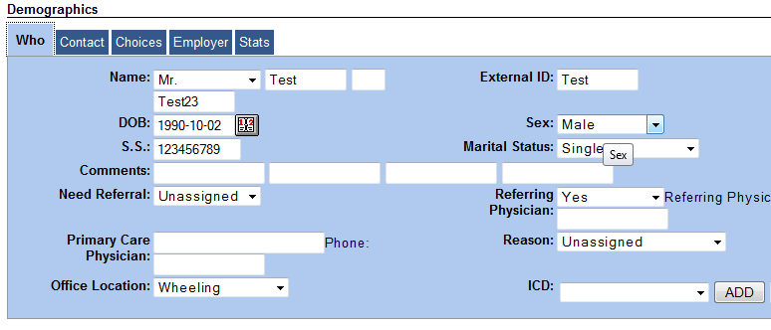

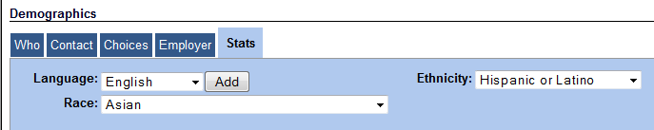

## Report ambulatory clinical quality measures to CMS/States

Description: In order to meet this objective, physicians must report clinical quality measures to CMS or to the state, depending on whether they are receiving incentive payments via Medicare or Medi-Cal.

Within the Clinical Quality Measure Objective, three of the quality measures will be “core” measures on which all physicians will have to report. If a provider feels that one of these core measures do not apply to his or her specialty, then that provider may report on one of three “alternate core” quality measures.

In addition, physicians will select three clinical quality measures from a list of 41 options. This will give physicians the flexibility to select measures that are most applicable to their practice specialty.

Objective: Report clinical quality measures to CMS or states.

Measure: For 2011, provide aggregate numerator and denominator through attestation; for 2012, electronically submit measures.

**Note**: - There are no cutoff percentages for the CQM’s

## Record smoking status for patients 13 years or older

Description: This objective and measure would simply require a physician to record whether a patient smokes. This objective does not include any requirement for a physician to offer tobacco cessation, although tobacco cessation is a required clinical quality measure.

Although opinions vary as to the age at which physicians should begin recording this data, the Office of the National Coordinator is using 13 years old to create consistency of data with the National Health Interview Survey.

Objective: Record smoking status for patients 13 years of age or older.

Measure: More than 50% of patients 13 years of age or older have smoking status recorded as structured data.

**Calculation:**

Numerator – The number of patients over the age of 13 with smoking status recorded as structured data.

Denominator – The number of unique patients over the age of 13 seen by the physician during the EHR Reporting Period.

Result – The resulting percentage must be more than 50% for the physician to meet this objective.

**Exclusions and Other Considerations:**

1. This objective is specific to smoking. Other types of tobacco use need not be recorded. Similarly, exposure to second-hand smoke need not be recorded.

2. Smoking status does not need to be updated every time the physician sees the patient.

3. A physician who does not see patients over the age of 13 is excluded from this measure.

4. A physician need not receive this information directly from the patient. Physicians who do not see the patient, for example radiologists, can receive this information from a referring physician.

5. This measure is based on unique patients, regardless of the number of times any individual patient is seen.

**How to mark**

If the patient is 13 years or older, then we need to mark the tobacco (smoking status), in the ‘lifestyle’ tab under the history of the patient.

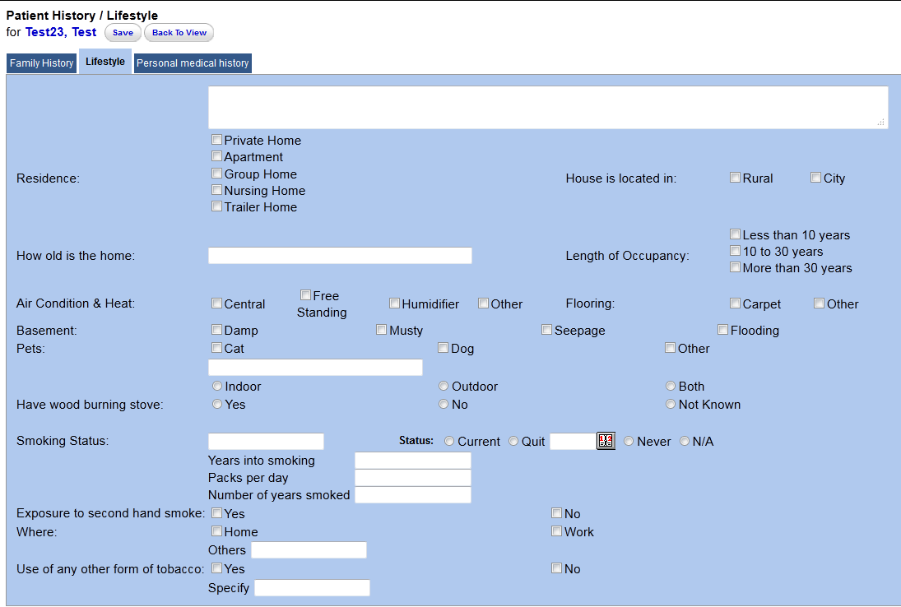

## Capability to exchange key clinical information among providers of care

This has been excluded from 2013 and 2014 core set.

## Maintain an up-to-date problem list of current and active diagnoses

Description: A list of current and active diagnoses, sometimes known as a “problem list,” is a list within a patient’s electronic record of current health problems.

Objective: Maintain up-to-date problem list of current and active diagnoses.

Measure: More than 80% of patients have at least one entry recorded as structured data.

**Calculation:**

Numerator – The number of unique patients seen by the physician who have at least one entry or an indication that no problems are known for the patient recorded as structured data.

Denominator – The number of unique patients seen by the physician during the EHR Reporting Period.

Result – The resulting percentage must be more than 80% in order for a physician to meet this objective.

**Exclusions and Other Considerations:**

1. The term “up-to-date” means the most recent diagnosis known to the physician.

2. The rule does not specify a standard that a physician must use in order to record a patient’s diagnosis (i.e., the rule does not specify ICD-9-CM-CM or SNOMED CT®).

3. A physician is allowed to record that a patient has no current diagnoses.

4. The calculation is based on unique patients seen by the physician, regardless of the number of times any individual patient is seen.

5. The list can include diagnoses from other physicians.

**How to mark**

We need to go and update the ‘Medical problems’ on the patient demographics page to mark the same.

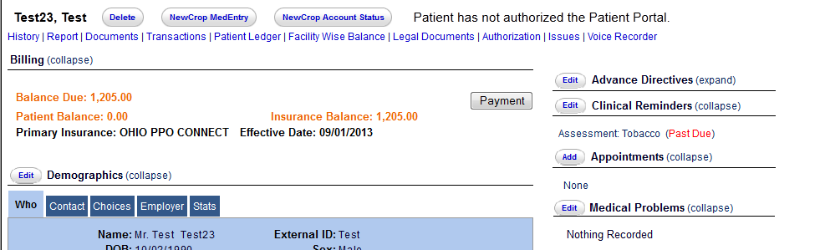

## Implement one clinical decision support rule

Description: Clinical decision support (CDS) tools prompt physicians regarding up-to-date evidence-based care. CDS uses information about the patient to generate real-time advice for the physician.

Objective: Implement one clinical decision support rule relevant to high clinical priority along with the ability to track compliance with the rule.

Measure: One clinical decision support rule implemented.

**Calculation:** Not applicable.

**Exclusions and Other Considerations:**

The physician selects the CDS tool to implement, based on the practice and specialty needs.

**How to mark**

We can do any clinical support rule. One of the examples of the same is ‘Tobacco cessation’.

In the patient history, under the lifestyle section, we can mark the smoking status and accordingly a clinical reminder will be created.

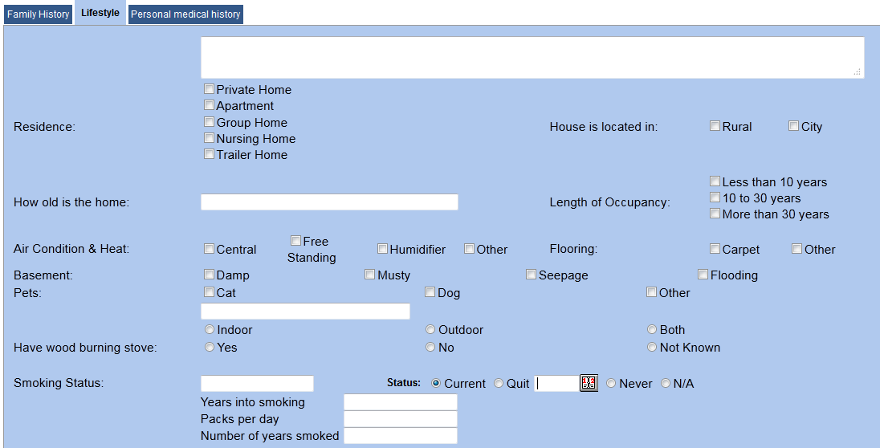

Now that, we have marked the above as ‘current’. If we now go to the patient demographics screen, we will find a clinical reminder for the tobacco intervention. Thus we have achieved a clinical decision support.

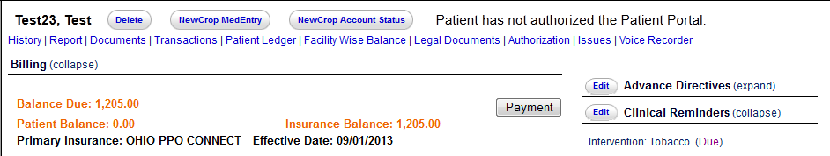

## Protect electronic health information

This is a process where the clinic needs to do internal security. There is a document which is a check list for the security measures.

# Menu Set

## Drug-formulary checks

Description: Drug-formulary checks allow physicians to check a patient’s health plan formulary for coverage of a medication. EHR systems allow physicians to disable these checks. This objective, on the other hand, requires them to be enabled.

## 

This objective is an optional “menu set” item for Stage 1, but will be required in Stage 2 of meaningful use.

Objective: Implement drug-formulary checks.

Measure: Drug formulary check system is implemented and has access to at least one internal or external drug formulary for the entire reporting period.

**Calculation:** Not applicable.

**Exclusions and Other Considerations:**

1. Physicians who write fewer than 100 prescriptions during the reporting period are excluded from this objective.

2. A physician only needs one formulary that can be queried.

**How to mark**

This criterion is automatically met by using the e-prescription.

## Generate lists of patients by specific conditions

Description: One of the capabilities that a Certified EHR system must contain is the ability to generate lists of patients based on diagnosis. For example, a physician could generate a list of all patients with Diabetes.

Lists such as this could be useful for researching trends, reaching out to groups of patients with similar conditions, or other quality improvement purposes.

Objective: Generate lists of patients by specific conditions to use for quality improvement, reduction of disparities, research, or outreach.

Measure: Generate at least one listing of patients with a specific condition.

**Calculation:** Not Applicable

**Exclusions and Other Considerations:**

1. The physician will choose which specific condition will be covered by the list.

2. The list does not need to be sent or transmitted; it only needs to be generated.

**How to generate the report**

We need to check the specific diagnosis as reportable in the Administration->services tab as shown below

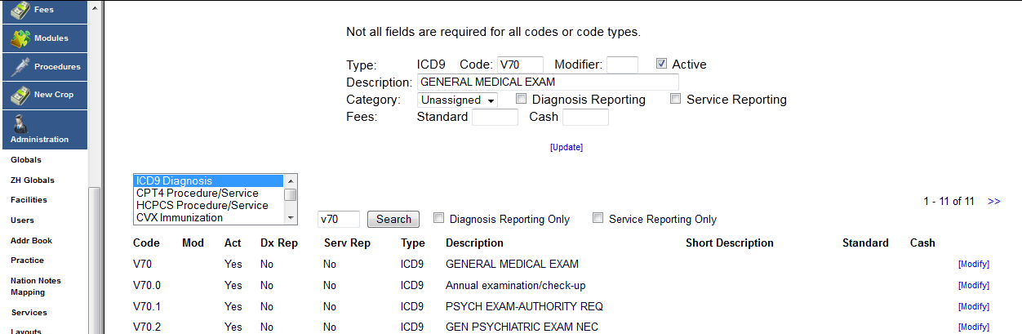

Once you check the diagnosis as reportable, then we can go and pull a report for the same from Reports->visits->syndromic surveillance, by selecting the diagnosis and pulling out the report between the applicable dates.

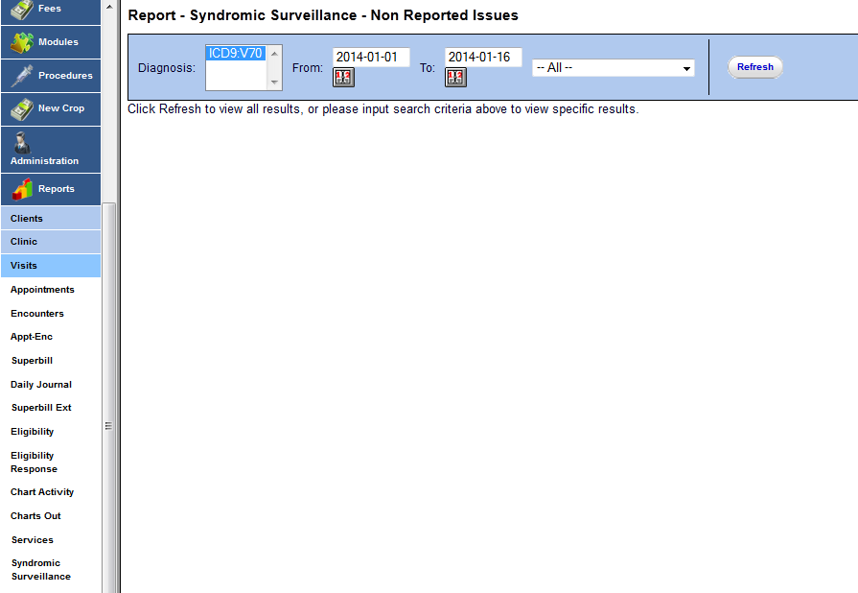

## Provide patients with timely electronic access to their health information

Description: One of the advantages of EHR adoption is the ability to engage patients in their own care. Certified EHR systems must include a “patient portal.” Through this portal, physicians will be able to give patients access to information about their diagnoses, lab results, and other clinical data online.

Objective: Provide patients with timely electronic access to their health information (including laboratory results, problem list, medication lists, and medication allergies).

Measure: More than 10% of patients are provided electronic access to information within 4 days or its being updated in the EHR, subject to the physician’s discretion to withhold certain information.

**Calculation:**

Numerator – The number of patients who have timely (available to the patient within four business days of being updated in the EHR) electronic access to their health information online.

Denominator – The number of unique patients seen by the physician during the EHR Reporting Period.

Result – The resulting percentage must be more than 10% for the physician to meet this objective.

**Exclusions and Other Considerations:**

1. Physicians are allowed to withhold information that would potentially be harmful to the patient.

2. The objective is based on the availability of the information, regardless of whether the patient chooses to access it.

**How to mark**

The patient portal access has to be given to the patients by giving allow patient portal as ‘Yes’ in the patient demographics page (under the choices section).

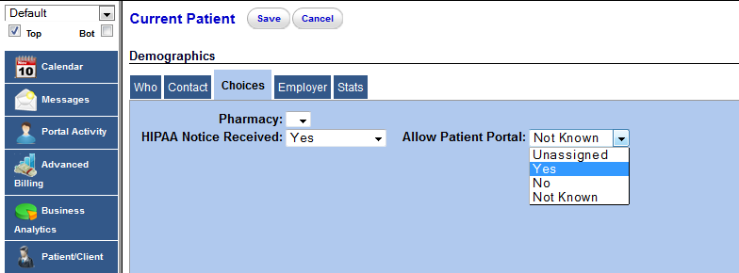

Once this is done, we can generate a username and password for the patient by clicking on the following button on the patient screen. Thus we can give the patient the necessary access.

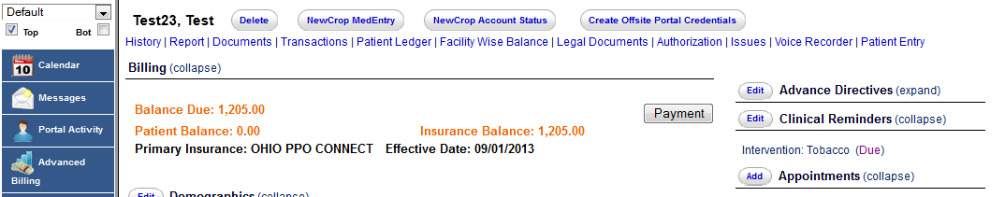

## Medication reconciliation

Description: The rule defines medication reconciliation as:

“the process of identifying the most accurate list of all medications that the patient is taking, including name, dosage, frequency and route, by comparing the medical record to an external list of medications obtained from a patient, hospital or other provider.”

Reconciliation is most often performed when a patient transitions from one care setting to another, such as being discharged from the hospital.

Objective: A physician who receives a patient from another setting of care should perform medication reconciliation.

Measure: Medication reconciliation is performed for more than 50% of transitions of care.

**Calculation:**

Numerator – Number of Patients for whom medication reconciliation was performed.

Denominator – Number of transitions of care during the EHR Reporting Period for which the physician was the receiving party.

Result – If the result of the calculation is more than 50%, the physician has met this requirement.

**Exclusions and Other Considerations:**

1. Reconciliation only needs to be performed when a physician receives a patient from another care setting, not when sending the patient to another setting.

2. A physician who does not receive any patients from another care setting during the EHR Reporting Period would be excluded from this objective.

**How to mark**

In the screen where the doctor enters the patient notes, there are a couple of check boxes which marks the numerator and the denominator.

Denominator: - We need to check off the transition of care patients in the check box shown below

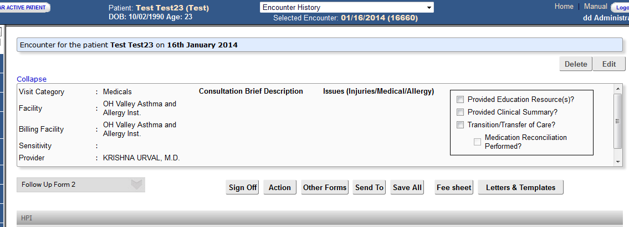

Once the transition of care is checked, a check box called ‘Medical Reconciliation Performed?’ is activated.

Numerator: - Check off the ‘Medical Reconciliation performed?’ checkbox and numerator will be taken.

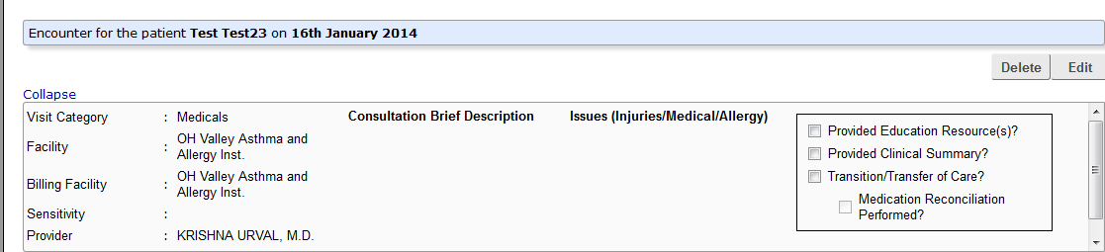

## Use certified EHR technology to identify patient-specific education resources and provide to patient, if appropriate

Description: Certified EHR systems will have the ability to send patients appropriate reminders, such as that it is time for an office visit or to renew a prescription. These reminders can be powerful tools for helping patients to take responsibility for their own care.

For the purposes of this objective, the reminder can be delivered either electronically or by hard copy, depending on the patient’s preference.

Objective: Send reminders to patients (per patient preference) for preventive and follow-up care.

Measure: More than 20% of patients 65 years of age or older or 5 years of age or younger are sent appropriate reminders.

**Calculation:**

Numerator – The number of patients who were sent an appropriate reminder.

Denominator – Number of unique patients 65 years or older or 5 years old or younger.

Result – The resulting percentage must be more than 20% for the physician to meet this objective.

**Exclusions and Other Considerations:**

1. If a physician has no patients over the age of 65 or under the age of 5, this objective would not apply to that physician.

2. The denominator for the calculation above includes all patients in the appropriate age range, whether they are seen during the EHR Reporting Period or not.

**How to mark**

The facility can search for appropriate materials from the below area of the EMR (Miscellaneous->Patient Education).

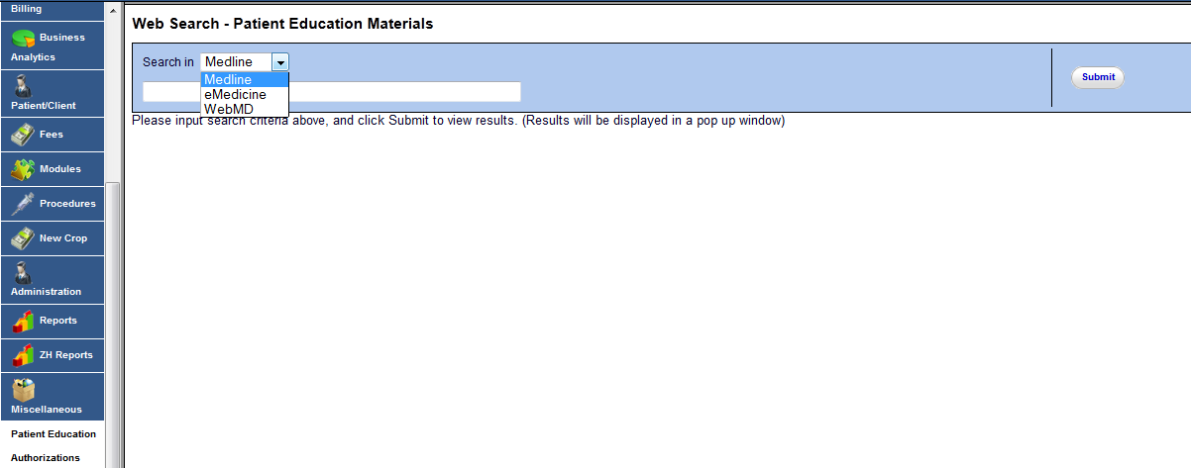

After collecting and stacking the patient education material, the facility needs to hand out the printed copies to the patients.

After having handed over the material, the following area on the forms needs to be checked. This needs to be done for 20% of the patients.

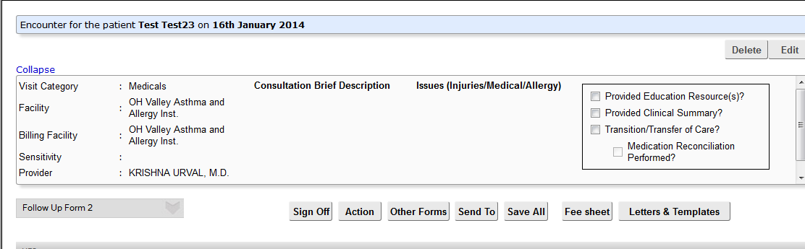

## Incorporate clinical lab test results as structured data

Description: Certified EHR systems will have the ability to record results of lab tests, and then transmit them either to other practitioners or to patients. This objective does not cover all lab tests, only those whose results are expressed in a positive/negative format, or as a number.

For Stage 1 of meaningful use, this is an optional, “menu set” objective.

Objective: Incorporate clinical laboratory test results into EHRs as structured data.

Measure: More than 40% of clinical laboratory test results whose results are in positive/negative or numerical format are incorporated into EHRs as structured data.

**Calculation:**

Numerator – The number of lab test results whose results are expressed in a positive/negative format or as a number which are incorporated as structured data.

Denominator – The total number of lab tests ordered by the physician whose results are expressed in a positive/negative format or as a number.

Result – If the result of the calculation is more than 40%, the physician has met this requirement.

**Exclusions and Other Considerations:**

1. This objective only requires the physician to enter the result into the EHR as structured data. The information can be received from the lab in any format (fax, telephone, regular mail, etc.).

2. A physician who does not order any lab tests during the EHR Reporting Period would be excluded from this requirement.

## Send reminders to patients per patient preference for preventive/follow up care

Description: Certified EHR systems will have the ability to send patients appropriate reminders, such as that it is time for an office visit or to renew a prescription. These reminders can be powerful tools for helping patients to take responsibility for their own care.

For the purposes of this objective, the reminder can be delivered either electronically or by hard copy, depending on the patient’s preference.

Objective: Send reminders to patients (per patient preference) for preventive and follow-up care.

Measure: More than 20% of patients 65 years of age or older or 5 years of age or younger are sent appropriate reminders.

**Calculation**:

Numerator – The number of patients who were sent an appropriate reminder.

Denominator – Number of unique patients 65 years or older or 5 years old or younger.

Result – The resulting percentage must be more than 20% for the physician to meet this objective.

**Exclusions and Other Considerations:**

1. If a physician has no patients over the age of 65 or under the age of 5, this objective would not apply to that physician.

2. The denominator for the calculation above includes all patients in the appropriate age range, whether they are seen during the EHR Reporting Period or not.

## Summary of care record for each transition of care/referrals

Description: for this objective, a physician would send (in any format) a summary care record when transitioning a patient to another care setting. A certified EHR system will be able to generate this record using entered patient information.

This purpose of this objective is to ensure that all of a patient’s health information follows them as they transition from one care setting to another. This can improve patient safety and reduce unnecessary treatments and testing.

Objective: The physician who transitions their patient to another setting of care or provider of care or refers their patient to another provider of care should provide summary care record for each transition of care or referral.

Measure: Summary of care record is provided for more than 50% of patient transitions or referrals.

**Calculation:**

Numerator – The number of referrals or transitions of care for which a summary care record is provided.

Denominator – The number of transitions or referrals during the EHR Reporting Period for which the physician was the transferring or referring partner.

Result – The resulting percentage must be more than 50% for the physician to meet this objective.

**Exclusions and Other Considerations:**

1. The objective does not specify how the summary care record is presented to the next provider.

2. Unlike medication reconciliation, this objective is performed by the physician transferring the patient, not the one receiving the patient.

3. A physician who does not transfer or refer any patients during the EHR Reporting Period would be excluded from this objective.

## Public Health objectives

At least one of the below mentioned public health objective’s need to be met

## Capability to submit electronic data to immunization registries/systems

Description: EHRs can automate the process of reporting administered immunizations to local immunization registries. Particularly in areas where there are functioning health information exchanges, EHRs can send this information electronically.

Objective: Capability to submit electronic data to immunization registries or immunization information systems and actual submission in accordance with applicable law and practice.

Measure: Perform at least one test of EHR’s capacity to submit electronic data to immunization registries and follow up submission if the test is successful (unless none of the immunization registries to which the physician submits such information have the capacity to receive the information electronically).

**Calculation**: Not applicable.

**Exclusions and Other Considerations**:

1. Physicians are allowed to report that their local immunization registry does not accept electronic submissions.

2. A physician who does not administer any immunizations during the EHR Reporting Period would be excluded from this objective.

3. Physicians are allowed to use “dummy” data (information on a fictional patient) for this test.

**How to achieve**

We have go and run the report for immunization in Reports->clients->Immunization Registry. Once we get the report for the prescribed date, we can send this to the registry.

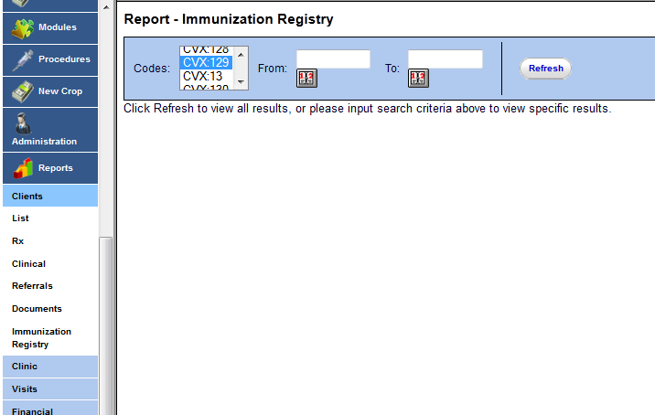

## Capability to provide electronic syndromic surveillance data to public health agencies

Description: According to the Center for Disease Control (CDC), the term “syndromic surveillance” applies to surveillance using health-related data that precede diagnosis and signal a sufficient probability of a case or an outbreak to warrant further public health response.

EHRs can enable physicians to report this data to local public health agencies and enable earlier public health response to potential outbreaks.

Objective: Submit electronic syndromic surveillance data to public health agencies.

Measure: Perform at least one test of data submission and follow-up submission (where public health agencies can accept electronic data)

**Calculation**: Not applicable.

**Exclusions and Other Considerations**:

1. Physicians are allowed to report that their local public health agency does not accept electronic submissions.

2. A physician who does not collect any reportable syndromic surveillance data during the EHR Reporting Period would be excluded from this objective.

3. Physicians are allowed to use “dummy” data (information on a fictional patient) for this test.

**How to generate the report**

We need to check the specific diagnosis as reportable in the Administration->services tab as shown below



Once you check the diagnosis as reportable, then we can go and pull a report for the same from Reports->visits->syndromic surveillance, by selecting the diagnosis and pulling out the report between the applicable dates.

